The Four Industrial Revolutions
A Clear and Comprehensive Guide
From Steam Engines to Artificial Intelligence:
How Technology Has Transformed Work, Society, and Everyday Life

An Educational Reference Document
Prepared June 2026

Contents
1. Introduction — What Is an Industrial Revolution?
2. The First Industrial Revolution (c. 1760–1840)
3. The Second Industrial Revolution (c. 1840–1914)
4. The Third Industrial Revolution (c. 1950–2000)
5. The Fourth Industrial Revolution (c. 2000–Present)
6. Comparing the Four Industrial Revolutions
7. Real-World Examples: How Each Revolution Changed Daily Life
8. Benefits, Risks, Challenges, and Ethical Questions
9. Conclusion
10. References

1. Introduction — What Is an Industrial Revolution?
An Industrial Revolution is a period of time during which there is a rapid and far-reaching change in the way goods are produced, the way people work, and the way societies are organised. The term does not describe a single invention or a single event. Instead, it describes a chain reaction: a small number of breakthrough technologies appear, and these breakthroughs combine with one another to transform almost every part of life — how people earn a living, where they live, how they travel, how they communicate, how long they live, and how they are educated.
Historians and economists generally agree that there have been four major industrial revolutions so far. Each one was built on top of the one before it, and each one happened faster than the last:
- The First Industrial Revolution (roughly 1760–1840) introduced mechanical production powered by water and steam, replacing hand-made goods with machine-made goods.
- The Second Industrial Revolution (roughly 1840–1914) introduced electricity, mass production, and new industries such as steel, chemicals, and oil.
- The Third Industrial Revolution (roughly 1950–2000) introduced electronics, computers, automation, and eventually the internet.
- The Fourth Industrial Revolution (roughly 2000–present) is currently unfolding, and is built around artificial intelligence, big data, robotics, the Internet of Things, and the merging of the physical, digital, and biological worlds.

It is helpful to think of these four revolutions not as separate, disconnected events, but as four overlapping waves. Each wave changes the kind of energy people use, the kind of machines they build, the kind of work they do, and the kind of society they live in. Figure 1 below shows the approximate timing of each revolution, along with some of the key inventions and energy sources associated with each one.
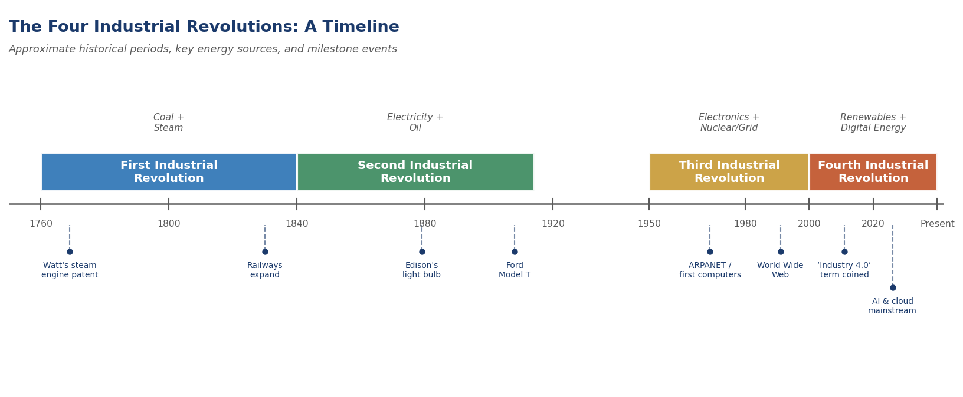
Figure 1. An overview timeline of the Four Industrial Revolutions, showing their approximate historical periods, dominant energy sources, and selected milestone events.

Why Do Industrial Revolutions Matter?
Industrial revolutions matter because they change the basic rules of everyday life for almost everyone, not just for factory workers or business owners. Before the First Industrial Revolution, most people in the world worked on farms, lived in small villages, and rarely travelled more than a short distance from where they were born. After four industrial revolutions, most people live in cities, travel internationally, communicate instantly with people on the other side of the planet, and have access to medicines, foods, and information that would have seemed like magic to someone living in the year 1750.
Each industrial revolution has also created new kinds of jobs while making older kinds of jobs disappear. For example, the First Industrial Revolution reduced the number of people needed for hand-weaving but created huge numbers of new jobs in factories, mines, and railways. The Fourth Industrial Revolution is now reducing the need for some routine office and factory jobs, while creating new jobs in data science, robotics, and renewable energy.
This document explains each of the four industrial revolutions in turn, using simple language and clear examples. It then compares them side by side, looks at how they changed everyday life, and discusses the benefits, risks, and ethical questions that come with rapid technological change — especially the questions raised by the Fourth Industrial Revolution, which is still happening today.

2. The First Industrial Revolution (c. 1760–1840)
The First Industrial Revolution began in Great Britain in the second half of the 18th century and gradually spread to Western Europe, North America, and beyond during the early 19th century. It marked the shift from an economy based mainly on farming and handmade goods to one based on machine-powered manufacturing, particularly in the textile industry.

2.1 Historical Period
Most historians date the First Industrial Revolution from around 1760 to around 1840, although the exact starting and ending points are debated and the process happened at different speeds in different countries. Britain is generally seen as the birthplace of this revolution, partly because it had large coal deposits, a strong trading economy, access to raw materials such as cotton from its overseas colonies, and a financial system that allowed entrepreneurs to borrow money to build factories and machines.

2.2 Main Causes
Several factors combined to make this revolution possible. No single cause was responsible — instead, multiple changes reinforced one another:
- Availability of coal and iron: Britain had large, accessible deposits of coal and iron ore, which provided the raw materials and fuel needed for new machines and factories.
- Agricultural improvements: Better farming methods (such as crop rotation and selective breeding of animals) meant that fewer farm workers were needed to feed the population, freeing up labour to move to towns and work in factories.
- Growing population: Britain's population grew significantly during the 18th century, providing both a larger workforce and a larger market for manufactured goods.
- Access to capital and trade: A developed banking system and profits from international trade (including the colonial trade in raw materials such as cotton) provided money that could be invested in new machinery and factories.
- Scientific and engineering progress: The period built on earlier scientific advances and a culture of practical experimentation, which encouraged inventors to design new machines to solve everyday production problems.
- Demand for goods: Growing domestic and overseas markets created strong demand for cloth, tools, and other manufactured products, giving entrepreneurs a financial incentive to find faster ways to produce them.

2.3 Key Inventions
A series of inventions — mostly related to textiles, power, and iron production — transformed manufacturing during this period. Some of the most important include:
- The Spinning Jenny (James Hargreaves, c. 1764): Allowed one worker to spin multiple threads of cotton at once, dramatically increasing the speed of yarn production compared to a single spinning wheel.
- The Water Frame (Richard Arkwright, 1769): A spinning machine powered by a water wheel, which allowed thread production to move out of homes and into purpose-built factories (‘mills’) located near rivers.
- The Spinning Mule (Samuel Crompton, 1779): Combined features of the Spinning Jenny and the Water Frame to produce strong, fine thread suitable for high-quality cloth.
- The Power Loom (Edmund Cartwright, 1785): A mechanised version of the traditional handloom, which used water or steam power to weave cloth much faster than a human weaver could by hand.
- The Improved Steam Engine (James Watt, patented 1769 and improved through the 1780s): Made steam power efficient and reliable enough to drive factory machinery, pumps, and (later) vehicles. This is often considered the single most important invention of the period.
- The Cotton Gin (Eli Whitney, 1793, United States): Mechanised the separation of cotton fibres from their seeds, dramatically increasing the supply of raw cotton available to British and American textile mills.
- Puddling and Rolling Processes for Iron (Henry Cort, 1780s): Improved methods of converting raw iron into high-quality wrought iron, supporting the construction of machines, bridges, and (later) railways.

2.4 The Steam Engine and the Power Revolution
Before the First Industrial Revolution, most machines were powered by human or animal muscle, or by water wheels and windmills. These power sources had serious limitations: water wheels could only be used near fast-flowing rivers, and the power they produced could not easily be increased or moved to a different location.
The steam engine changed this completely. By burning coal to heat water and produce steam, and then using the pressure of that steam to push a piston back and forth, a steam engine could produce mechanical power almost anywhere — not just next to a river. James Watt's improvements to the steam engine in the 1760s, 1770s, and 1780s made steam engines far more fuel-efficient and reliable than earlier designs (such as the Newcomen engine, which had mainly been used to pump water out of mines).
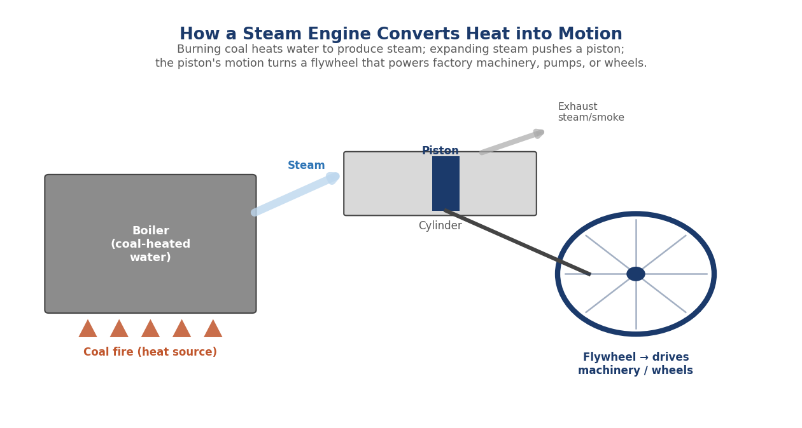
Figure 2. A simplified diagram of how a steam engine works: coal is burned to heat water into steam, the expanding steam pushes a piston, and the piston's motion turns a flywheel that can power factory machinery, pumps, or the wheels of a locomotive.
Once steam engines became reliable and affordable, they could be installed in factories of any size, in any location, freeing manufacturers from their dependence on rivers and streams. Steam power could also be scaled up simply by building a bigger engine and burning more coal, which meant that factories could keep growing in size and output. Steam power eventually spread beyond factories to transport, most famously in steam locomotives (from the 1820s) and steamships.

2.5 Textile Production: From Cottage Industry to Factory System
Textile production — making thread and cloth, mainly from cotton and wool — was the industry most transformed by the First Industrial Revolution, and it is often used as the clearest example of how the revolution changed everyday work.
Before this period, textile production usually followed the ‘domestic system’ or ‘cottage industry’ model. A merchant would deliver raw cotton or wool to families living in villages, who would spin it into thread and weave it into cloth in their own homes, often using simple hand-powered spinning wheels and looms. This work fit around farming and other household tasks, but it was slow, and the amount of cloth that could be produced was strictly limited by how many hours a family could spend at their wheel and loom.
The new spinning and weaving machines described above were too large, too expensive, and too power-hungry to fit in a typical home. Instead, they were installed together in large buildings — factories, often called ‘mills’ — where dozens or hundreds of machines could be powered by a single large water wheel or steam engine. Workers moved from their homes to these factories, where they operated machines for fixed hours each day, often six days a week.
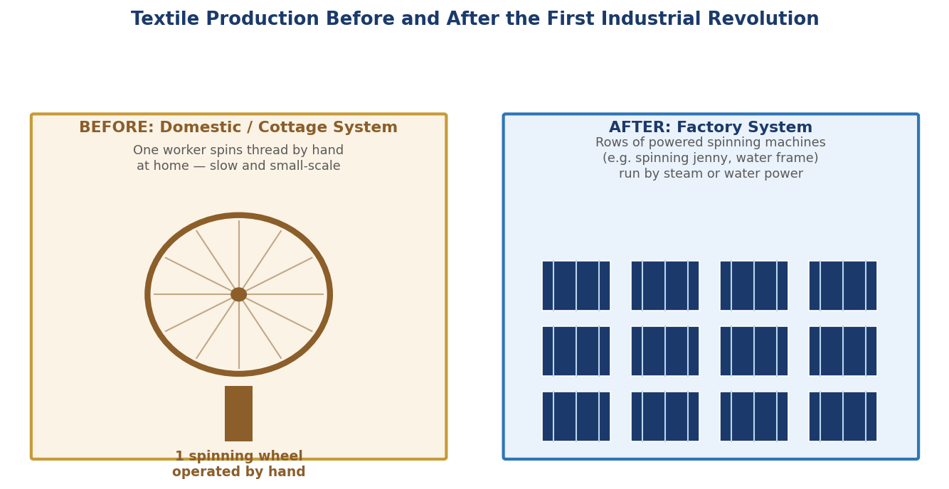
Figure 3. Textile production before and after the First Industrial Revolution. Previously, a single worker used a hand-powered spinning wheel at home; afterwards, rows of powered spinning machines in factories could produce far more thread, far more quickly.
This shift from the domestic system to the factory system had enormous consequences. It concentrated production (and workers) in specific locations, usually near rivers, coalfields, or ports. It created an entirely new pattern of daily life built around the factory clock rather than the rhythms of farming and the seasons. And it dramatically increased the amount of cloth that could be produced, which lowered prices and made clothing more affordable — while also putting many traditional hand-spinners and hand-weavers out of work.

2.6 Coal and Iron Industries
Coal and iron were the two raw materials that made everything else in the First Industrial Revolution possible, and their production grew together in a self-reinforcing cycle.
Coal was needed as fuel for steam engines, and as the number of steam engines increased, so did the demand for coal. At the same time, better steam engines were used to pump water out of coal mines, allowing miners to dig deeper and extract more coal than ever before. Iron was needed to build the steam engines, machines, and (later) railway tracks and locomotives themselves. Improvements in iron-making — particularly Henry Cort's puddling process, which removed impurities from iron more efficiently — made it possible to produce stronger iron in larger quantities and at lower cost.
This created a cycle: more coal mining required more steam engines and machinery, which required more iron; more iron production required more coal for the furnaces; and the transport of both coal and iron created demand for better roads, canals, and eventually railways, which themselves were built from iron and powered by coal-fired steam engines. Figure 4 illustrates this self-reinforcing cycle.
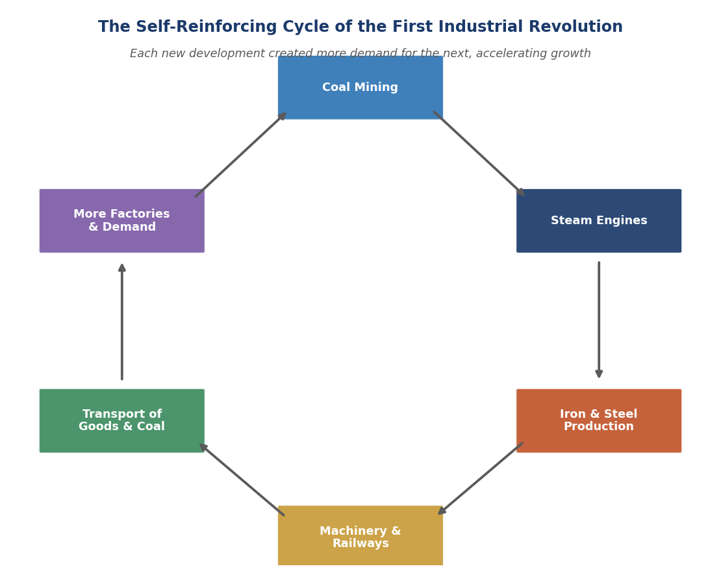
Figure 4. The self-reinforcing cycle of the First Industrial Revolution. Growth in any one area — coal mining, steam engines, iron and steel production, machinery and railways, transport, or factory demand — created more demand for the others, accelerating overall economic growth.

2.7 Changes in Agriculture, Transport, and Society

Agriculture
Although the First Industrial Revolution is mostly remembered for factories and machines, important changes were also happening in farming. New crop rotation techniques (such as the four-field system, which rotated wheat, turnips, barley, and clover) kept soil fertile without leaving fields empty, while selective breeding produced larger and healthier livestock. Improved ploughs and other tools, often made from the new cheaper iron, made farm work more efficient. The overall effect was that fewer farm workers were needed to produce enough food for the growing population — which meant that more people were available, and often needed, to move to towns and work in the new factories.

Transport
Before this period, moving heavy goods over land was slow, difficult, and expensive — carts on muddy roads could only carry small loads short distances. The First Industrial Revolution brought two major transport improvements. First, a network of canals was built across Britain from the 1760s onwards, allowing horse-drawn barges to carry heavy goods such as coal, iron, and finished cloth far more cheaply than carts could. Second, towards the end of this period, the first steam railways appeared: the Stockton and Darlington Railway opened in 1825, and the Liverpool and Manchester Railway opened in 1830, demonstrating that steam locomotives could reliably pull both goods and passengers. Railways would go on to become one of the defining technologies of the Second Industrial Revolution.

Society
The social changes of this period were as significant as the technological ones. Millions of people moved from rural villages to rapidly growing industrial towns and cities such as Manchester, Birmingham, and Leeds, in search of factory work. This rapid urbanisation often happened faster than towns could build adequate housing, sanitation, or clean water supplies, leading to overcrowding and serious public health problems in many industrial towns during this period.
Working conditions in early factories and mines were often harsh by today's standards: long hours (commonly 12 to 14 hours a day, six days a week), dangerous machinery with few safety guards, and the widespread employment of children, sometimes as young as five or six years old, in mines and textile mills. Over time, these conditions led to the growth of trade unions and to the first government factory laws, such as the Factory Act of 1833 in Britain, which began to limit the working hours of children and require basic safety measures — though full reform took many more decades.
At the same time, the new factory system created an entirely new social class: industrial workers (sometimes called the ‘working class’ or ‘proletariat’), who depended on wages from factory owners rather than on land or traditional crafts. A new class of factory owners and industrialists also grew wealthy, and the gap between rich and poor in industrial cities was often stark and visible.

3. The Second Industrial Revolution (c. 1840–1914)
The Second Industrial Revolution — sometimes called the ‘Technological Revolution’ — built directly on the foundations laid by the first. Where the First Industrial Revolution had been centred on Britain, textiles, and steam power, the Second Industrial Revolution was a much more international phenomenon, involving the United States, Germany, France, and other countries, and was centred on electricity, steel, chemicals, oil, and entirely new methods of mass production.

3.1 Historical Period
The Second Industrial Revolution is generally dated from around 1840 (or sometimes 1870) to the start of the First World War in 1914. Some of its key technologies — such as the Bessemer process for making steel — emerged in the 1850s, while others — such as the assembly line and widespread household electricity — did not become common until the early 20th century. This revolution overlapped with the final decades of the First Industrial Revolution and gradually merged into it, which is one reason historians sometimes treat the two as a single, longer process of industrialisation.

3.2 Electricity
If steam was the defining power source of the First Industrial Revolution, electricity was the defining power source of the Second. Electricity offered something steam power could not: it could be generated in one location (a power station) and then transmitted through wires to be used in many different locations — homes, offices, streets, and factories — often far away from the power station itself.
- Early experiments: Scientists such as Michael Faraday had discovered the basic principles of electromagnetism and electrical generation in the 1830s, but it took several more decades before electricity could be generated, distributed, and used economically on a large scale.
- The electric light bulb: Thomas Edison (in the United States) and Joseph Swan (in Britain) both developed practical incandescent light bulbs around 1879–1880. Reliable electric lighting meant that factories, shops, and streets could be lit cheaply and safely, extending working and shopping hours into the evening.
- Power stations and the electrical grid: Edison opened one of the first commercial power stations in New York in 1882. Over the following decades, electrical grids — networks of power stations, cables, and substations — spread across cities and then across entire countries, eventually reaching rural areas too.
- Electric motors: Electric motors could be much smaller and more flexible than steam engines, and could be installed individually in machines on a factory floor, rather than requiring every machine to be connected by belts to one giant central steam engine. This made factories safer, quieter, and easier to reorganise.
By the early 20th century, electricity was beginning to power not just lighting but also trams, factory machinery, household appliances, and — as discussed below — new forms of communication such as the telephone.

3.3 Mass Production
Mass production means manufacturing large numbers of identical products quickly and at low cost, usually by breaking the production process down into small, simple, repeatable steps and using specialised machinery and workers for each step. While factories already existed during the First Industrial Revolution, the Second Industrial Revolution introduced new techniques that took this idea much further.
- Interchangeable parts: Earlier in the 19th century, manufacturers (particularly in the United States, for products such as firearms and sewing machines) began making components to standard, precise measurements, so that any part would fit into any finished product. This meant that broken parts could be easily replaced, and that different stages of production could be separated and specialised.
- Scientific management: In the early 20th century, engineers such as Frederick Winslow Taylor studied how factory work could be organised more efficiently, breaking complex jobs down into simple, timed, repeatable tasks.
- The moving assembly line: The most famous example of mass production is Henry Ford's moving assembly line, introduced for the Ford Model T car in 1913. Instead of workers moving around a stationary car to assemble it, the car itself moved along a conveyor belt, with each worker performing one specific task as it passed by. This reduced the time needed to build a single car from over twelve hours to around ninety minutes, and dramatically lowered the cost of each car.
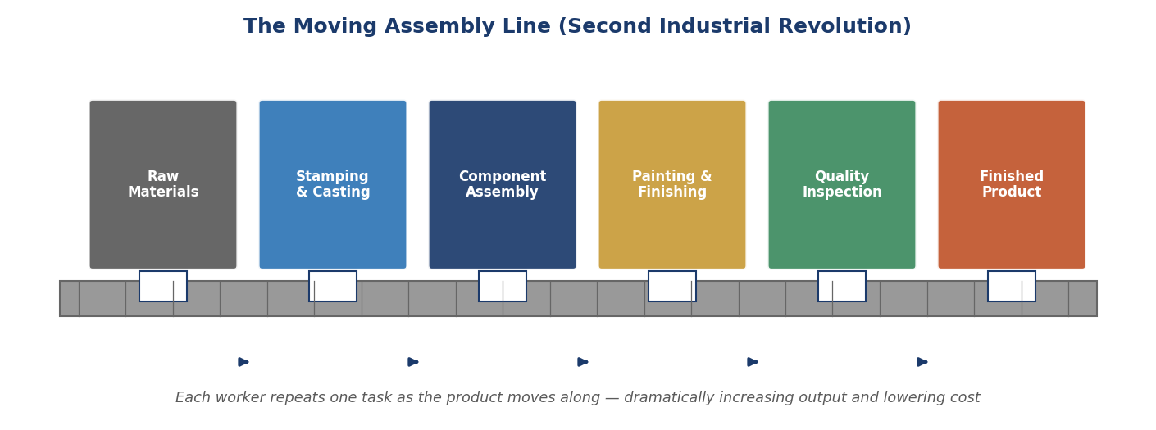
Figure 5. The moving assembly line, pioneered by Henry Ford for car manufacturing in 1913. A product moves along a conveyor belt while each worker repeats a single specialised task — a method that became the model for mass production across many industries.
Mass production made many products — from cars to bicycles to canned food — affordable to ordinary working people for the first time, not just to the wealthy. It also changed the nature of factory work itself: rather than being a skilled craftsperson who made an entire product from start to finish, a factory worker increasingly performed one small, repetitive task, over and over, for an entire shift.

3.4 Steel, Chemicals, and Oil Industries

Steel
Steel is a stronger, more durable form of iron, but before the mid-19th century it was difficult and expensive to produce in large quantities. The Bessemer process, developed by Henry Bessemer and patented in 1856, blew air through molten iron to remove impurities quickly and cheaply, making steel production dramatically faster and less expensive. Steel could be used for railway tracks (which lasted far longer than iron tracks), for the frames of tall buildings and bridges, for ships, and eventually for cars and machinery of all kinds. Countries with strong steel industries — particularly the United States, Germany, and Britain — became major industrial powers during this period.

Chemicals
The chemical industry grew rapidly during the Second Industrial Revolution, producing new dyes, fertilisers, explosives, and synthetic materials. For example, synthetic dyes (the first of which, a purple dye called mauveine, was discovered accidentally by William Perkin in 1856) replaced expensive natural dyes and created a major new industry, particularly in Germany. New chemical fertilisers, based on research into nitrogen and phosphorus, helped farmers produce much larger harvests, supporting the growing populations of industrial cities.

Oil
Petroleum (crude oil) became an increasingly important resource during this period, initially mainly for producing kerosene, which was used for lighting (before electric lighting became widespread) and for lubricating machinery. The world's modern oil industry is often dated to 1859, when Edwin Drake drilled one of the first commercially successful oil wells in Pennsylvania, USA. By the end of this period, oil was also beginning to be used as a fuel for the new internal combustion engines that would power cars, ships, and (eventually) aircraft — setting the stage for oil's central role throughout the 20th century.

3.5 Railways, Telegraph, Telephone, and Communication

Railways
While early railways appeared at the end of the First Industrial Revolution, it was during the Second Industrial Revolution that railway networks expanded explosively across the world. Railways made it possible to move people and goods overland faster, more reliably, and more cheaply than ever before, connecting inland cities to ports and to each other. The growth of railways also created enormous demand for steel (for tracks, locomotives, and bridges) and coal (for fuel), reinforcing the industrial economy.
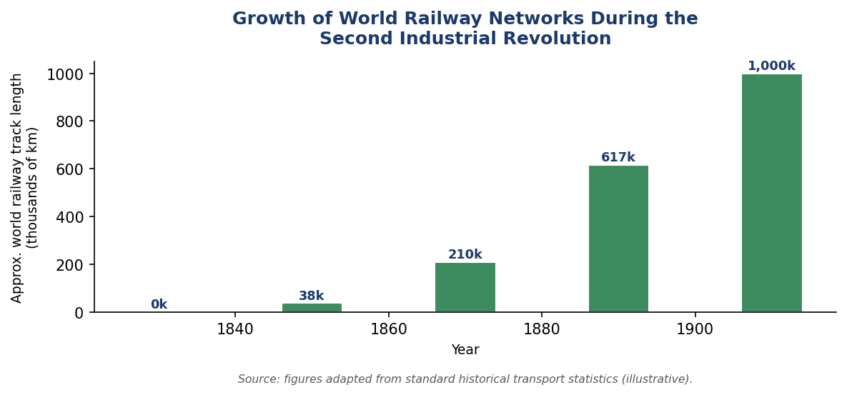
Figure 6. Approximate growth of world railway track length during the Second Industrial Revolution. The rapid expansion of railway networks connected cities, ports, and industrial regions, transforming both trade and personal travel.

The Telegraph
The electric telegraph, which became widely used from the 1840s onwards, allowed messages to be sent almost instantly over long distances using electrical signals along wires, encoded using systems such as Morse code (a pattern of short and long signals, or ‘dots’ and ‘dashes’, representing letters and numbers). Before the telegraph, sending a message overseas could take weeks, limited by how fast a ship could sail. The first successful transatlantic telegraph cable was completed in 1866, connecting Europe and North America and reducing communication time from weeks to minutes.

The Telephone
The telephone, patented by Alexander Graham Bell in 1876, allowed people to transmit the sound of their voice directly over wires, rather than having to translate messages into and out of code. Telephone networks expanded rapidly in cities and, over subsequent decades, between cities and countries, gradually making it possible for ordinary people — not just businesses and governments — to communicate over long distances in real time.
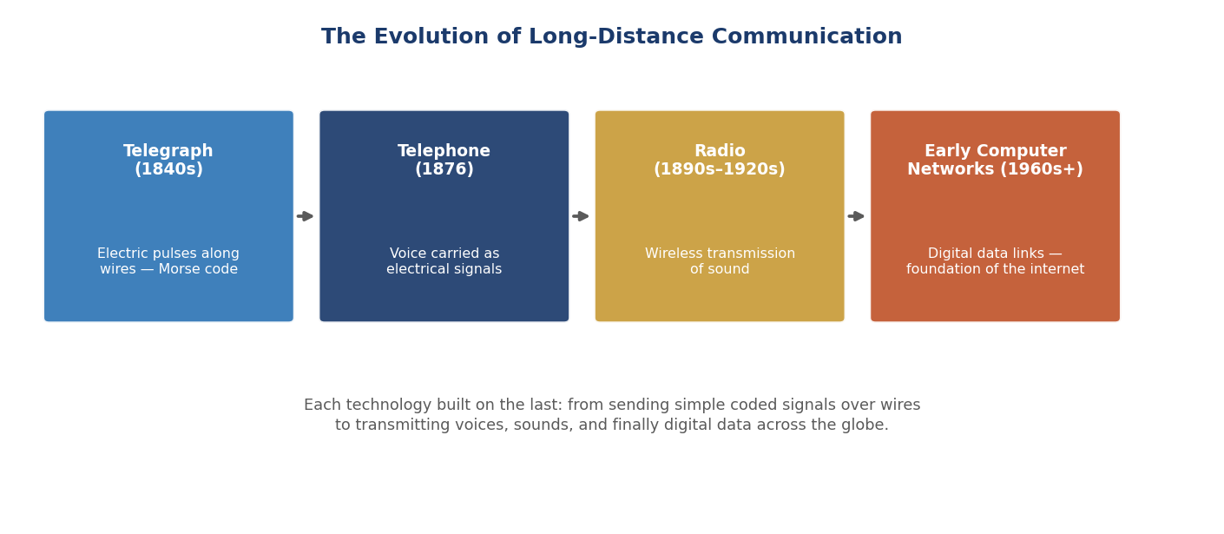
Figure 7. The evolution of long-distance communication from the telegraph (1840s) through the telephone (1876) and radio (1890s–1920s) to early computer networks (1960s onwards), each technology building on the principles of the one before it.

3.6 Factories, Urbanisation, and Global Trade

Factories
Factories during the Second Industrial Revolution became larger, more mechanised, and increasingly organised around the principles of mass production described above. Large companies — sometimes called ‘corporations’ or, in their largest forms, ‘trusts’ or ‘monopolies’ — emerged, particularly in the United States, controlling huge shares of industries such as steel, oil, and railways. This period saw the rise of some of the largest companies the world had ever seen, employing tens of thousands of workers across multiple factories and countries.

Urbanisation
The trend of urbanisation that began during the First Industrial Revolution accelerated dramatically during the Second. Cities such as New York, Chicago, Berlin, and Tokyo grew at extraordinary speed, as factories, railways, and new job opportunities drew millions of people from rural areas — both from within their own countries and, especially in the case of the United States, through large-scale international migration. By the early 20th century, for the first time in human history, large numbers of people in industrialised countries lived in cities rather than in the countryside.
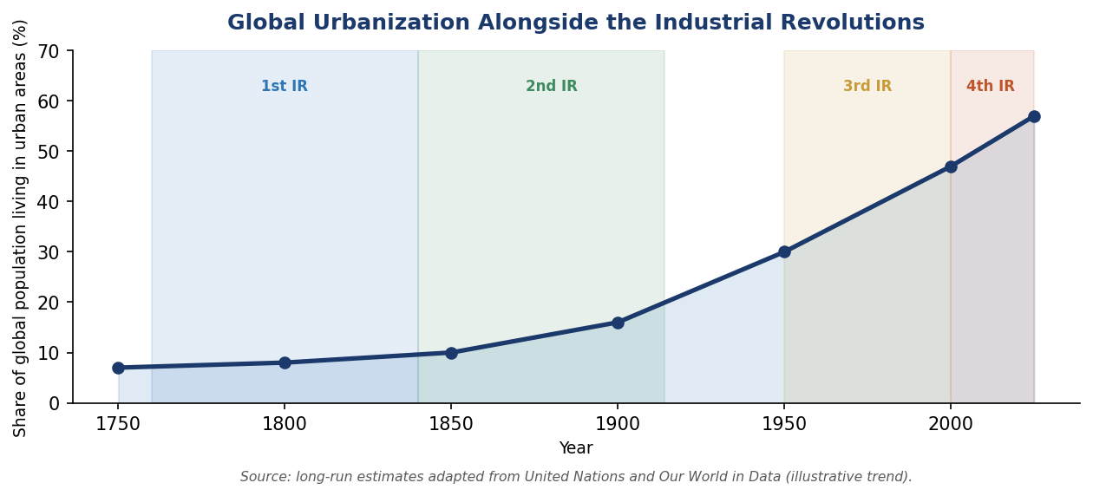
Figure 8. The share of the world's population living in urban areas increased steadily from around 1750 onwards, with the pace of urbanisation accelerating sharply during the Second Industrial Revolution and continuing through the Third and Fourth.

Global Trade
Faster ships (including steamships, which did not depend on the wind), railways connecting inland production to coastal ports, and the telegraph (which allowed merchants to communicate prices and orders across the world almost instantly) combined to create a genuinely global economy for the first time. Raw materials could be shipped from one continent, manufactured into finished goods on another, and sold on a third. Refrigerated ships, introduced in the late 19th century, even allowed perishable foods such as meat and fruit to be transported across oceans, changing diets around the world. This period is sometimes described as the first great wave of ‘globalisation’, with international trade growing faster than ever before in history up to that point.

4. The Third Industrial Revolution (c. 1950–2000)
The Third Industrial Revolution — often called the ‘Digital Revolution’ — represents a shift away from purely mechanical and electrical technology towards electronics, computing, and information. Where the first two industrial revolutions were primarily about producing physical goods more efficiently, the Third Industrial Revolution was about processing, storing, and communicating information — a resource that, unlike coal or steel, can be copied and shared at almost no additional cost.

4.1 Historical Period
The Third Industrial Revolution is generally dated from around the middle of the 20th century, particularly after the Second World War, through to roughly the year 2000. Its foundations were laid by inventions of the 1940s and 1950s (such as the transistor and early computers), but its effects became truly widespread — reaching ordinary homes and workplaces — mainly from the 1970s onwards, with the spread of personal computers, and from the 1990s onwards, with the spread of the internet.

4.2 Electronics
The Third Industrial Revolution would not have been possible without a series of breakthroughs in electronics — the branch of physics and engineering concerned with controlling the flow of electricity through devices to process information.
- The transistor (1947): Invented at Bell Labs in the United States, the transistor is a tiny device that can switch or amplify electrical signals. Transistors were smaller, cheaper, more reliable, and used far less power than the vacuum tubes that had been used in earlier electronic devices (including early computers and radios).
- The integrated circuit (late 1950s): Engineers found ways to combine many transistors, along with other electronic components, onto a single small piece of silicon — known as a ‘chip’ or ‘integrated circuit’. This made electronic devices dramatically smaller and cheaper to manufacture.
- The microprocessor (early 1970s): A microprocessor is a chip that contains an entire computer's central processing unit. The first commercially successful microprocessor, the Intel 4004, was released in 1971. Microprocessors made it possible to build affordable, compact computers, and later to embed computing power into all kinds of everyday devices.
Over the following decades, the number of transistors that could be fitted onto a single chip increased exponentially — a pattern often referred to as ‘Moore's Law’, after Intel co-founder Gordon Moore, who observed in 1965 that the number of transistors on a chip seemed to double roughly every two years. This relentless improvement in computing power, combined with falling costs, is one of the central stories of the Third Industrial Revolution.

4.3 Computers
Computers evolved dramatically during this period, from room-sized machines used only by governments, universities, and very large companies, to small, affordable devices found in homes and offices around the world.
- Mainframe computers (1950s–1960s): Early electronic computers, such as ENIAC (completed in 1945) and its successors, were enormous, expensive machines that filled entire rooms, required teams of specialist staff to operate, and were used mainly for scientific calculations, military applications, and large-scale business data processing (such as payroll and accounting for big companies).
- Minicomputers (1960s–1970s): Smaller and cheaper than mainframes, minicomputers brought computing power within reach of universities, smaller businesses, and laboratories — though they were still far too expensive and complex for most individuals.
- Personal computers (1970s–1980s): The arrival of the microprocessor made it possible to build computers small and cheap enough for individuals and small businesses to own. Machines such as the Apple II (1977), the IBM PC (1981), and later affordable home computers brought computing into offices, schools, and homes for the first time.
- Graphical user interfaces (1980s–1990s): Early computers were operated by typing text commands. The development of graphical interfaces — using a mouse to click on icons, windows, and menus, popularised by the Apple Macintosh (1984) and Microsoft Windows — made computers far easier for non-specialists to use.
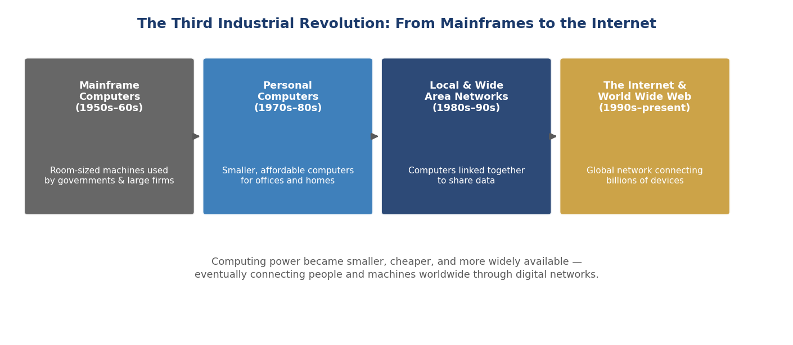
Figure 9. The evolution of computing during the Third Industrial Revolution, from room-sized mainframe computers used by governments and large organisations, to personal computers, to networks that eventually became the internet.

4.4 Automation
Automation means using machines, computers, and control systems to perform tasks that previously required direct human control or supervision, often in manufacturing and industrial processes.
- Industrial robots: The first industrial robots were introduced in factories from the early 1960s onwards, initially for simple, repetitive, and often dangerous tasks such as welding car parts or moving heavy materials. Over subsequent decades, robots became more precise, more flexible, and able to perform increasingly complex assembly tasks, particularly in car manufacturing and electronics.
- Programmable logic controllers (PLCs): Introduced in the late 1960s, PLCs are small computers designed to control machinery and industrial processes — for example, controlling the sequence of operations on a factory production line, or managing the systems in a power plant. PLCs made factory processes more precise, more reliable, and easier to reprogram when production needs changed.
- Computer-aided design and manufacturing (CAD/CAM): Engineers and designers increasingly used computers to design products and to control the machinery that manufactured them, improving precision and making it easier to modify designs without having to rebuild physical tools and moulds from scratch.
Automation changed the nature of factory work once again: rather than performing repetitive manual tasks themselves, many workers increasingly monitored, programmed, and maintained automated machines and robots — a shift towards more technical, but often less physically demanding, roles.

4.5 The Internet
The internet — a global network connecting computer networks together — is one of the most transformative technologies of the Third Industrial Revolution, and arguably of all human history.
- ARPANET (1969): The internet's direct ancestor was ARPANET, a network funded by the United States Department of Defense, which initially connected a small number of university and research computers, allowing them to share data and computing resources.
- TCP/IP and the growth of networks (1970s–1980s): The development of common technical standards — particularly the TCP/IP protocols, adopted as the standard for ARPANET in 1983 — allowed many different computer networks around the world to connect to each other and exchange information, forming the basis of what we now call ‘the internet’.
- The World Wide Web (1989–1991): Although the internet existed before the 1990s, it was difficult for non-specialists to use. The World Wide Web, invented by Tim Berners-Lee in 1989 and made publicly available in 1991, introduced a much simpler way to navigate and share information online: documents (‘web pages’) linked to each other through clickable ‘hyperlinks’, viewed using a ‘web browser’.
- Mass adoption (1990s): Through the 1990s, the combination of affordable personal computers, web browsers, and growing access to internet connections (initially often through telephone lines) brought the internet into ordinary homes, schools, and businesses for the first time, setting the stage for the even more connected world of the Fourth Industrial Revolution.

4.6 Information Technologies
Beyond computers and the internet themselves, the Third Industrial Revolution introduced a wide range of related information technologies that changed how data was stored, processed, and shared:
- Digital storage: Information that had previously been stored on paper, film, or magnetic tape in large physical archives could increasingly be stored digitally — first on devices such as floppy disks and hard drives, and later on optical discs (such as CDs and DVDs) — taking up far less physical space and making copying and searching much easier.
- Software industries: As computers became more widespread, an entirely new industry grew up around writing, selling, and supporting software — the programs and instructions that tell computers what to do — separate from the companies that manufactured the computer hardware itself.
- Databases: Businesses and governments increasingly stored and managed large amounts of information — customer records, financial transactions, scientific data — in computerised databases, which could be searched and analysed far more quickly than equivalent paper records.

4.7 Digital Communication and Globalisation
The combination of computers, the internet, and new digital communication technologies dramatically accelerated globalisation — the process by which economies, cultures, and societies around the world become more interconnected.
- Email: Electronic mail, which became widely used from the 1990s onwards, allowed people to send written messages, documents, and (eventually) other files almost instantly to recipients anywhere in the world, at a fraction of the cost and time of postal mail or international phone calls.
- Mobile phones: Mobile telephone networks expanded rapidly from the 1980s and especially the 1990s onwards, eventually allowing people to make calls — and later send text messages — from almost anywhere, rather than being tied to a fixed telephone line.
- Global supply chains: Digital communication made it far easier for companies to coordinate complex international operations — for example, designing a product in one country, manufacturing components in several others, assembling the final product in yet another, and selling it worldwide — all coordinated through computer systems and digital communication in real time.
- E-commerce: Towards the end of this period, the first online shops and services began to appear, foreshadowing the much larger role that online commerce would play in the Fourth Industrial Revolution.
By the year 2000, the foundations had been laid for a world in which computing power was cheap and widespread, most businesses depended on digital information systems, and an increasing share of communication — personal, commercial, and governmental — took place over digital networks. These foundations set the stage directly for the Fourth Industrial Revolution.

5. The Fourth Industrial Revolution (c. 2000–Present)
The Fourth Industrial Revolution — sometimes called ‘Industry 4.0’, a term first popularised in Germany around 2011 — is the revolution we are currently living through. It builds on the digital technologies of the Third Industrial Revolution but goes further, blurring the boundaries between the physical, digital, and biological worlds. Where the Third Industrial Revolution was mainly about computers processing information, the Fourth Industrial Revolution is about intelligent systems that can sense their environment, make decisions, communicate with each other, and increasingly act in the physical world with limited human involvement.
Because the Fourth Industrial Revolution is still unfolding, it is harder to describe with the same historical certainty as the first three. However, a number of key technologies are widely recognised as its central pillars, illustrated in Figure 10 and discussed in detail below.
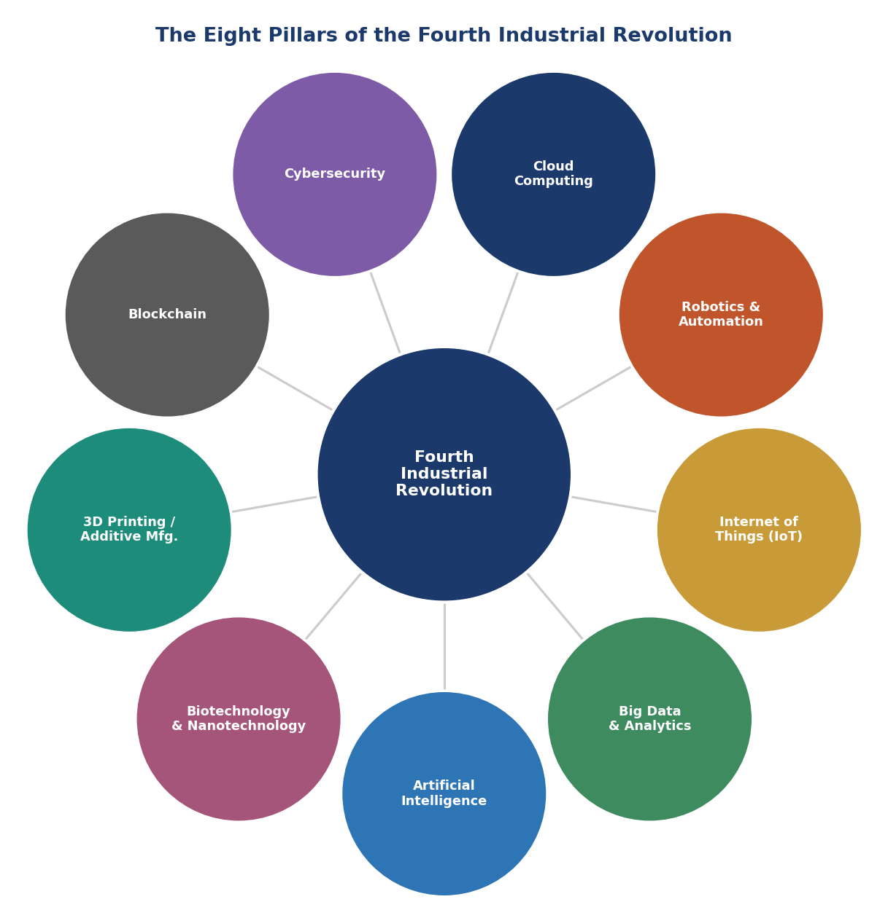
Figure 10. The eight technological pillars commonly associated with the Fourth Industrial Revolution: artificial intelligence, big data and analytics, the Internet of Things, robotics and automation, cloud computing, cybersecurity, blockchain, 3D printing, and biotechnology and nanotechnology. These technologies are deeply interconnected and often reinforce one another.

5.1 Artificial Intelligence (AI)
Artificial intelligence refers to computer systems that can perform tasks which would normally require human intelligence — such as recognising images, understanding language, making predictions, or playing strategy games. While the idea of AI dates back to the mid-20th century, AI has become dramatically more capable and widely used since around 2010, mainly due to a combination of more powerful computer hardware, much larger amounts of available data, and improved mathematical techniques.
- Machine learning: Machine learning is a major branch of AI in which computer systems improve their performance on a task by learning patterns from data, rather than being explicitly programmed with rules for every situation. For example, a machine learning system can learn to recognise photos of cats by being shown many thousands of example photos, rather than being given a written description of what a cat looks like.
- Deep learning and neural networks: A particularly powerful form of machine learning, inspired loosely by the structure of the human brain, uses many layers of interconnected mathematical ‘neurons’ to find complex patterns in data. Deep learning has driven major advances in image recognition, speech recognition, language translation, and — more recently — the generation of text, images, and other content.
- Everyday applications: AI is now used in voice assistants on smartphones, recommendation systems on streaming and shopping websites, spam filters in email, navigation apps that predict traffic, fraud detection in banking, and medical tools that help doctors analyse scans and test results.
AI is often described as a ‘general-purpose technology’, meaning that — like electricity or the steam engine before it — it is not limited to one industry, but has the potential to affect almost every sector of the economy and many aspects of daily life.

5.2 Machine Learning and Big Data
Machine learning and big data are closely linked: machine learning systems generally need very large amounts of data to learn from, and the growth of digital technology over recent decades has created vastly more data than ever existed before.
- What is ‘big data’?: Big data refers to extremely large and complex sets of data — too large to be processed using traditional methods — generated by sources such as social media activity, sensors, online transactions, mobile phones, and scientific research. Big data is often described using three key characteristics: volume (the sheer amount of data), velocity (how quickly it is generated and needs to be processed), and variety (the many different types and formats of data, such as text, images, video, and numerical data).
- Data analytics: Data analytics refers to the techniques used to examine large datasets in order to find useful patterns, trends, and insights — for example, a retailer analysing sales data to predict which products will be popular next season, or a city analysing traffic data to improve public transport routes.
- The relationship to AI: Many of the most impressive recent advances in AI have been made possible by training machine learning systems on enormous datasets — for example, systems that can translate between languages have been trained on millions of translated documents, and systems that can generate images or text have been trained on vast collections of existing images and text.
The combination of big data and machine learning allows organisations to make decisions and predictions that would have been impossible — or would have taken far too long — using traditional methods, but it also raises important questions about privacy and data security, discussed later in this document.

5.3 The Internet of Things (IoT)
The Internet of Things refers to the growing network of everyday physical objects — not just computers and phones — that are connected to the internet and can collect, send, and receive data.
- Examples of IoT devices: Smart thermostats that learn your heating preferences and can be controlled from a phone; fitness trackers and smartwatches that monitor heart rate, sleep, and activity; smart factory sensors that monitor the temperature, vibration, or wear of machinery; connected cars that can report their location, fuel level, and performance; smart agricultural sensors that monitor soil moisture and crop conditions.
- Why it matters: By connecting physical objects to the internet, the IoT allows real-world conditions to be monitored remotely and continuously, often automatically triggering actions — for example, a smart irrigation system that waters crops only when soil sensors detect they are dry, saving water compared to a fixed watering schedule.
- Scale: Billions of devices around the world are now connected through the IoT, and this number continues to grow rapidly as sensors become cheaper and wireless connectivity becomes more widespread.

5.4 Robotics and Automation
Robotics in the Fourth Industrial Revolution goes beyond the industrial robots of the Third Industrial Revolution, which mainly performed fixed, repetitive tasks in controlled factory environments.
- Collaborative robots (‘cobots’): Unlike older industrial robots, which often had to be kept in separate caged areas for safety, modern collaborative robots are designed to work safely alongside humans, often helping with tasks that require both human judgement and robotic precision or strength.
- Autonomous mobile robots: Robots that can navigate and move around independently — for example, robots that move products around warehouses, or robotic vacuum cleaners in homes — use sensors, cameras, and AI to understand and move through their environment without needing a fixed track or pre-programmed path.
- Service robots: Robots are increasingly used outside traditional manufacturing, including in healthcare (for example, robots that assist with surgery or help with rehabilitation), agriculture (robots that can identify and pick ripe fruit), and logistics (robots that sort and deliver packages).
- Autonomous vehicles: Self-driving cars, trucks, and drones use a combination of sensors, cameras, AI, and connectivity to navigate without a human driver, though fully autonomous vehicles are still being tested and gradually introduced in different parts of the world.

5.5 Cloud Computing
Cloud computing means using computing resources — such as data storage, processing power, and software — that are provided over the internet by a remote provider, rather than relying entirely on hardware owned and maintained locally.
- How it works: Instead of a company buying and maintaining its own large computer servers, it can rent computing resources from a cloud provider, paying only for what it uses, and scaling up or down as needed — for example, a website might temporarily use much more computing power during a busy sales period, and less during quiet periods.
- Benefits: Cloud computing has made powerful computing resources accessible to small businesses and individuals who could never have afforded to build their own data centres, and has made it easier to store and access data and applications from anywhere with an internet connection.
- Role in the Fourth Industrial Revolution: Cloud computing provides much of the underlying infrastructure for other Fourth Industrial Revolution technologies — for example, the data collected by IoT devices is often sent to cloud servers for storage and analysis, and many AI systems run on cloud computing platforms.
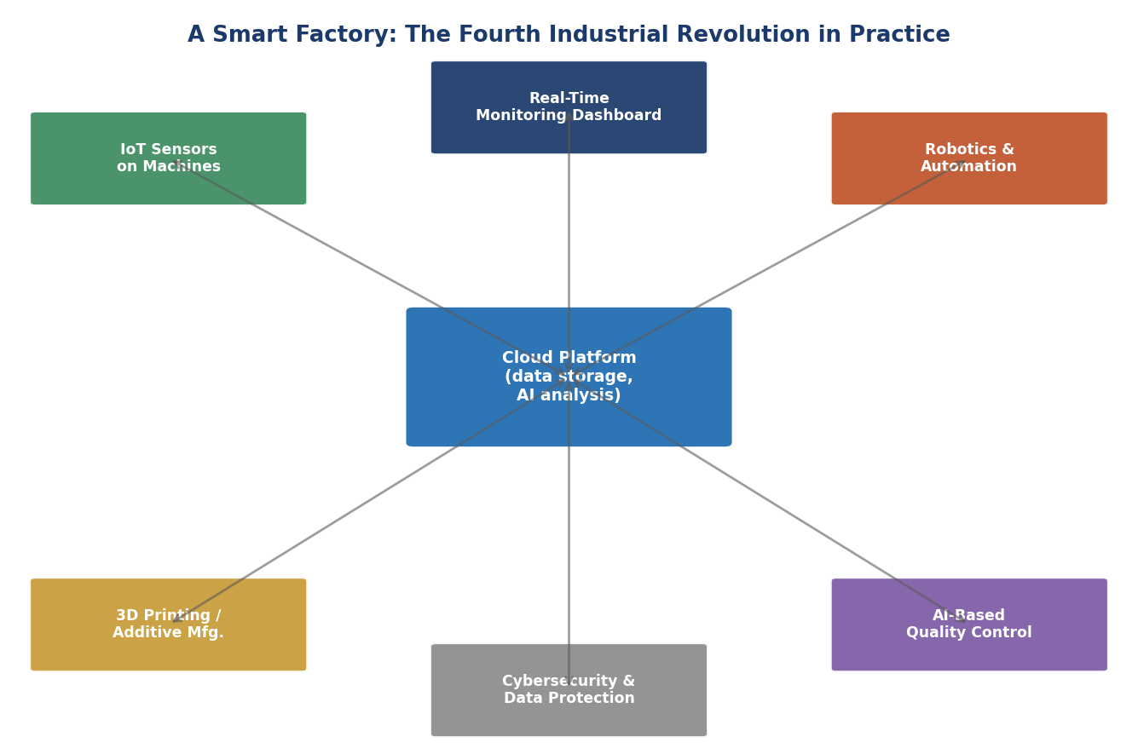
Figure 11. A simplified illustration of a 'smart factory': IoT sensors on machines feed data to a cloud platform for AI-based analysis, which supports robotics and automation, 3D printing, real-time monitoring dashboards, AI-based quality control, and is protected throughout by cybersecurity measures.

5.6 Cybersecurity
As more of daily life, business, and infrastructure depends on connected digital systems, protecting those systems from unauthorised access, damage, or disruption — cybersecurity — has become increasingly important.
- Why it matters more now: In earlier industrial revolutions, sabotaging a factory or stealing information usually required physical access. In the Fourth Industrial Revolution, a cyberattack launched from anywhere in the world can potentially disrupt factories, hospitals, power grids, financial systems, or personal devices — without the attacker ever being physically present.
- Common threats: These include malicious software (‘malware’) that can damage or take control of systems; ‘phishing’ attempts that trick people into revealing passwords or other sensitive information; and ‘ransomware’, which locks access to data or systems until a payment is made.
- Protective measures: Organisations use techniques such as encryption (scrambling data so it can only be read by authorised parties), firewalls (which control what network traffic is allowed in and out of a system), regular software updates (which fix known security weaknesses), and staff training (since many cyberattacks rely on tricking people rather than purely technical weaknesses).
Cybersecurity is sometimes described as a constant ‘arms race’ between those who build and defend systems and those who try to find and exploit weaknesses in them, and it is a growing field of employment in its own right.

5.7 Blockchain
A blockchain is a way of recording information — such as a list of transactions — across many computers at once, in a way that is very difficult to alter after the fact, without needing a single central organisation (such as a bank or government) to manage and verify the records.
- How it works (in simple terms): Information is grouped into ‘blocks’, each of which contains a reference to the previous block, forming a ‘chain’. Copies of this chain are stored across many different computers, and changing any block would require changing all the later blocks across most of these computers at the same time — which is extremely difficult to do without being detected.
- Cryptocurrencies: The best-known application of blockchain technology is cryptocurrency — digital forms of money, such as Bitcoin (introduced in 2009), that can be transferred between people without needing a bank to process the transaction.
- Other applications: Beyond cryptocurrency, blockchain-style technology is being explored for tracking the origin and movement of goods through supply chains (for example, verifying that food has come from where it claims to), for managing digital identities, and for recording ownership of digital assets.
Blockchain technology is still relatively new, and while it has generated enormous interest and investment, many of its potential applications beyond cryptocurrency are still being tested and developed.

5.8 3D Printing (Additive Manufacturing)
3D printing, also known as additive manufacturing, builds physical objects by adding material layer by layer, based on a digital design — the opposite of traditional manufacturing methods, which often work by cutting, drilling, or moulding material away from a larger block (‘subtractive’ manufacturing).
- How it works: A digital 3D model of an object is created using design software, and a 3D printer then builds the object by depositing material — commonly plastic, but also metal, resin, and even some food and biological materials — in thin layers, one on top of another, until the object is complete.
- Advantages: 3D printing can produce complex shapes that would be difficult or impossible to make using traditional methods, allows products to be customised easily (for example, a prosthetic limb made to fit one specific person), and can be useful for making small numbers of parts — such as prototypes, spare parts, or specialised medical devices — without the high costs of setting up traditional mass-production equipment.
- Limitations: For very large quantities of identical, simple items, traditional mass-production methods are often still faster and cheaper than 3D printing.

5.9 Biotechnology
Biotechnology involves using living organisms, or parts of living organisms (such as cells, genes, or proteins), to develop new products and technologies. While biotechnology is not new, the Fourth Industrial Revolution has dramatically increased its speed, precision, and scope, often by combining it with computing and AI.
- Gene editing: Techniques such as CRISPR, developed in the 2010s, allow scientists to make precise changes to the DNA of living organisms — with potential applications including treating genetic diseases, developing crops that are more resistant to pests or drought, and researching new medicines.
- Genomics: The cost of reading an individual's entire genetic code (their ‘genome’) has fallen dramatically — from billions of dollars for the first complete human genome sequence in the early 2000s to a few hundred dollars today — making personalised medicine, based on an individual's genetic makeup, increasingly practical.
- Synthetic biology: Scientists can now design and build new biological systems — for example, microorganisms engineered to produce useful substances such as medicines, fuels, or materials.
Biotechnology is closely linked to other Fourth Industrial Revolution technologies: AI is increasingly used to help design new proteins or predict how genetic changes will affect an organism, and big data techniques are used to analyse the enormous amounts of information generated by genetic sequencing.

5.10 Nanotechnology
Nanotechnology involves designing, creating, and manipulating materials and devices at an extremely small scale — typically measured in nanometres (one nanometre is one-billionth of a metre, far smaller than anything visible to the naked eye, and only a few times larger than individual atoms).
- Why scale matters: Materials can behave very differently at the nanoscale compared to their normal, everyday scale — for example, becoming stronger, more chemically reactive, or better at conducting electricity. This opens up possibilities for new materials with properties that would be impossible to achieve in larger forms.
- Applications: Nanotechnology is used in a wide range of products, including stronger and lighter materials for use in aircraft and sports equipment, more effective sunscreens and cosmetics, electronic components (modern computer chips already use features measured in nanometres), and medical applications such as targeted drug delivery, where medicine is designed to be released only at a specific location in the body.
Like biotechnology, nanotechnology often works closely with other Fourth Industrial Revolution technologies — for example, AI can help researchers design new nanomaterials with specific desired properties, dramatically speeding up the process of discovery compared to traditional trial-and-error methods.

5.11 Smart Factories and Autonomous Systems
Many of the technologies described above come together in the idea of the ‘smart factory’ — a manufacturing facility in which machines, products, and systems are connected, monitored, and often controlled with minimal direct human intervention.
- Connected machinery: Sensors throughout a smart factory continuously monitor the condition and performance of machines, allowing problems to be detected — and sometimes fixed automatically, or flagged for maintenance — before they cause a breakdown (an approach known as ‘predictive maintenance’).
- Flexible production: Unlike traditional assembly lines, which are often set up to produce one specific product in very large quantities, smart factories can sometimes be reconfigured quickly to produce different products, or even to customise individual products, in response to changing demand.
- Digital twins: Some smart factories use ‘digital twins’ — detailed computer models of physical machines or entire production lines — to test changes, predict problems, and optimise performance before making changes to the real, physical equipment.
- Autonomous systems beyond the factory: The same underlying ideas — sensors, connectivity, data analysis, and automated decision-making — are being applied well beyond manufacturing, including in autonomous vehicles, automated warehouses, smart electricity grids that can balance supply and demand automatically, and smart cities that aim to manage traffic, energy use, and public services more efficiently.
Together, these technologies represent a shift towards systems that do not just follow fixed instructions, but can sense, analyse, learn, and adapt — a fundamentally different kind of automation from that of the Third Industrial Revolution.

6. Comparing the Four Industrial Revolutions
Having looked at each industrial revolution in detail, it is useful to step back and compare them side by side. While each revolution had its own unique technologies and characteristics, some clear patterns emerge: each revolution introduced a new, more flexible energy source; each made production faster, cheaper, and more flexible; and each had profound effects on where and how people lived and worked. Table 1 below summarises the main technologies, energy sources, economic effects, social changes, and global impact of each revolution.
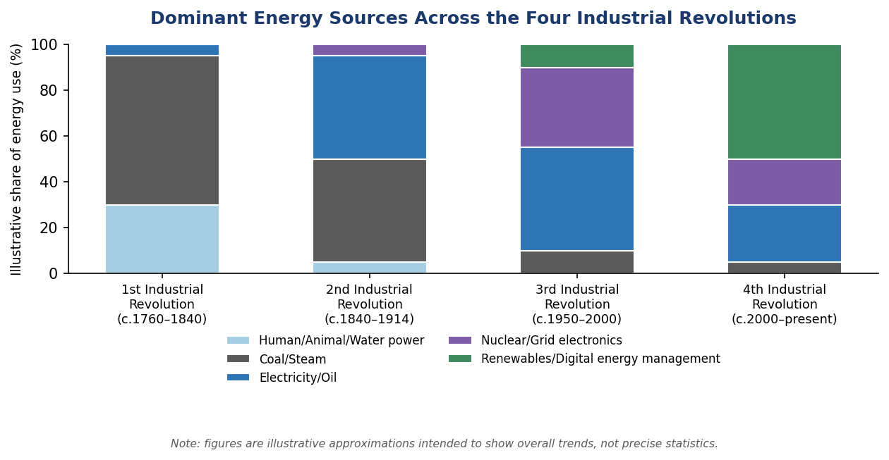
Figure 12. An illustrative comparison of the dominant energy sources associated with each Industrial Revolution. Each revolution did not completely replace earlier energy sources, but shifted the balance towards new sources that offered greater flexibility, efficiency, or lower emissions.

Aspect | First Industrial Revolution (c. 1760–1840) | Second Industrial Revolution (c. 1840–1914) | Third Industrial Revolution (c. 1950–2000) | Fourth Industrial Revolution (c. 2000–present)
Main technologies | Steam engine  Mechanised textile machinery  Iron production | Electricity & light bulb  Steel (Bessemer process)  Internal combustion engine  Telegraph & telephone | Transistors & microchips  Personal computers  The internet & World Wide Web | Artificial intelligence  IoT, robotics, cloud computing  Blockchain, 3D printing, biotech
Main energy source | Coal  Water power | Coal  Electricity  Oil (emerging) | Electricity  Oil  Nuclear power (in some countries) | Electricity (increasingly renewable)  Digital energy management
Where production happened | Water-powered mills near rivers  Early steam-powered factories | Large factories in industrial cities  Near coalfields, ports, railways | Factories with computer-controlled machinery  Offices with computers | Smart factories  Globally distributed, connected systems
Typical new jobs created | Factory machine operators  Coal miners  Railway workers (late period) | Assembly-line workers  Electricians  Telephone operators  Office clerks | Computer programmers  IT technicians  Call-centre and service-sector workers | Data scientists  AI/robotics engineers  Renewable-energy technicians  Cybersecurity specialists
Major social change | Mass migration from countryside to industrial towns  Rise of factory working class | Rapid growth of large cities  Rise of large corporations  First wave of modern globalisation | Spread of computers and information into homes and offices  Growth of service economy | Always-connected digital lifestyles  Remote and flexible work  Concerns about automation and jobs
Global impact | Began in Britain, spread to Western Europe & North America | Spread to USA, Germany, Japan & beyond; first global trade networks | Spread worldwide via personal computers & the early internet | Highly globalised; rapid spread of technology, but uneven access between regions
Table 1. A side-by-side comparison of the main technologies, energy sources, locations of production, typical new jobs, major social changes, and global impact associated with each of the four Industrial Revolutions.

6.1 What Stayed the Same?
Despite their differences, several patterns appear in every industrial revolution:
- New energy sources unlock new possibilities: Each revolution introduced a more flexible, more powerful, or more widely available energy source — from water and steam, to electricity and oil, to electronics and (increasingly) renewable energy — and this new energy source enabled new kinds of machines and processes.
- Production becomes faster, cheaper, and more flexible: Each revolution found new ways to produce more goods (or process more information) with less time, less cost, or less direct human effort than before.
- Old jobs disappear, new jobs appear: Every revolution has eliminated some kinds of work while creating other kinds of work that did not exist before — though the transition has often been difficult for the workers and communities affected.
- Cities grow, and societies become more connected: Each revolution has, directly or indirectly, encouraged people to live closer together (in towns and cities) and has improved communication and trade between different regions and countries.
- Concerns about pace of change: In every period, some people have worried that technological change is happening too fast, that it benefits some groups more than others, or that it creates new risks — concerns that are explored further in Section 8.

6.2 What Is Different About the Fourth Industrial Revolution?
While the Fourth Industrial Revolution follows the same broad pattern as the previous three, several features make it distinctive:
- Speed: Each industrial revolution has unfolded faster than the one before it. The First Industrial Revolution took place over roughly 80 years; many of the core technologies of the Fourth Industrial Revolution have become widespread within just 10–15 years.
- Convergence: Earlier revolutions were often associated with one or two dominant technologies (steam engines; electricity and mass production; computers and the internet). The Fourth Industrial Revolution involves many different technologies — AI, robotics, biotechnology, nanotechnology, and more — converging and reinforcing one another simultaneously.
- Blurring of physical, digital, and biological boundaries: Previous revolutions mostly changed how physical goods were produced, or how information was processed. The Fourth Industrial Revolution increasingly connects the physical world (through IoT and robotics), the digital world (through AI and cloud computing), and the biological world (through biotechnology and genomics) into single, integrated systems.
- Global reach from the start: Because so much of the Fourth Industrial Revolution depends on digital networks that already span the globe, new technologies can spread to many countries almost simultaneously, rather than gradually moving from one country to the next over decades, as happened with earlier revolutions.

7. Real-World Examples: How Each Revolution Changed Daily Life
Reading about the technologies and dates of each industrial revolution can feel abstract. This section brings the four revolutions to life with concrete, everyday examples — showing how an ordinary person's daily life, work, education, health, transport, and communication changed during each period.

7.1 Work
- First Industrial Revolution: A weaver who once worked from home, at their own pace, weaving cloth on a handloom between farming tasks, might instead travel each day to a large mill, where they operated a power loom for 12–14 hours, following a fixed schedule set by the factory's steam engine and bell.
- Second Industrial Revolution: A worker in a car factory might spend their entire shift performing one single task — for example, attaching a single component — over and over, as the car moved past them on a conveyor belt, rather than building an entire vehicle by hand as a skilled craftsperson might have done before.
- Third Industrial Revolution: An office worker who once typed letters on a typewriter, filed paper documents in cabinets, and sent messages by post might instead use a personal computer to write documents, store them digitally, and send them instantly by email.
- Fourth Industrial Revolution: A factory worker today might spend part of their time monitoring a dashboard that shows real-time data from dozens of connected machines, using AI-generated alerts to decide when a machine needs maintenance — sometimes working partly from home, connected to the factory's systems remotely.

7.2 Education
- First Industrial Revolution: Formal education was uncommon for most children, especially those from working families, many of whom began work in factories or mines at a very young age. Public, compulsory education systems began to develop partly in response to concerns about child labour during this period.
- Second Industrial Revolution: As economies needed more literate and numerate workers — for example, to read instructions, keep records, or operate increasingly complex machinery — many countries introduced compulsory primary education for children.
- Third Industrial Revolution: Computers began to appear in schools from the 1980s onwards, and by the 1990s, learning basic computer skills was becoming an important part of education in many countries.
- Fourth Industrial Revolution: Students can access online courses, video lectures, and educational software from anywhere in the world; AI-based tools can provide personalised feedback on schoolwork; and ‘digital literacy’ — understanding how to use, and think critically about, digital technology — is now considered an essential skill.

7.3 Industry and Manufacturing
- First Industrial Revolution: A small workshop with a handful of craftspeople making finished goods slowly by hand was replaced, in many industries, by a factory containing dozens or hundreds of machines, all powered by a single steam engine, producing far larger quantities of standardised goods.
- Second Industrial Revolution: A factory that once relied on one giant steam engine connected by belts to every machine could instead give each machine its own electric motor, making the factory layout far more flexible and allowing much larger-scale, continuous production through methods like the assembly line.
- Third Industrial Revolution: Computer-controlled machine tools could cut, shape, and assemble materials with much greater precision and consistency than human workers using manual tools, and could be reprogrammed for new designs far more easily than mechanical equipment could be physically reconfigured.
- Fourth Industrial Revolution: Sensors throughout a factory continuously monitor every machine; if a machine starts to show signs of wear, the system can automatically schedule maintenance before it breaks down, reducing costly unplanned stoppages — an approach known as predictive maintenance.

7.4 Transport
- First Industrial Revolution: A journey of 100 miles, which might once have taken several days by horse and cart on poor roads, could be completed in a single day by canal boat, and — by the very end of this period — in just a few hours by steam train.
- Second Industrial Revolution: Railway networks expanded so extensively that long-distance travel within a country, which had once been a major undertaking, became routine for ordinary people; meanwhile, the first cars (powered by the new internal combustion engine) began to appear on roads.
- Third Industrial Revolution: Air travel became affordable to ordinary people (not just the wealthy) for the first time, computer systems were used to manage increasingly complex air traffic and railway scheduling, and early satellite navigation systems began to be developed.
- Fourth Industrial Revolution: A smartphone app can show real-time public transport arrival times, calculate the fastest route accounting for current traffic conditions, and — in some cities — summon a ride-sharing vehicle; meanwhile, self-driving vehicle technology is being tested and gradually introduced.

7.5 Healthcare
- First Industrial Revolution: Medical understanding of disease was still limited, and rapid urbanisation — often without adequate clean water or sanitation — contributed to the spread of diseases such as cholera and typhoid in industrial towns.
- Second Industrial Revolution: Scientific advances such as germ theory (the understanding that many diseases are caused by microorganisms) led to major improvements in public health, including better sanitation systems, and laid the groundwork for modern medicine, including the development of vaccines for diseases such as rabies and, later, diphtheria.
- Third Industrial Revolution: Medical imaging technologies such as computed tomography (CT) scans and magnetic resonance imaging (MRI), which rely on computers to process data into detailed images of the inside of the body, transformed the diagnosis of many conditions.
- Fourth Industrial Revolution: AI systems can help analyse medical scans to detect signs of disease, sometimes spotting patterns that are difficult for the human eye to see; wearable devices can continuously monitor heart rate and other indicators, alerting users or doctors to potential health issues; and genomic technologies are beginning to enable medicine tailored to an individual's genetic makeup.

7.6 Communication
- First Industrial Revolution: Sending a message to a friend or relative in another town or country relied on physical transport — a letter carried by horse, coach, or ship — and could take days, weeks, or even months, depending on the distance.
- Second Industrial Revolution: The telegraph allowed urgent messages to be sent across continents in minutes using coded electrical signals, and the telephone, introduced later in this period, allowed people to speak directly to each other over long distances for the first time.
- Third Industrial Revolution: Email allowed written messages and documents to be sent instantly and at almost no cost, and — by the end of this period — mobile phones were beginning to allow people to communicate while away from a fixed location.
- Fourth Industrial Revolution: Video calls allow people on opposite sides of the world to see and speak to each other in real time, free instant messaging apps allow constant communication, and social media platforms allow individuals to share information, photos, and videos with large audiences instantly.

7.7 Science and Research
- First Industrial Revolution: Scientific experiments were typically conducted by individuals or small groups, often using simple equipment, and the results of research could take months or years to be shared with other scientists, usually through printed books and journals distributed by post or ship.
- Second Industrial Revolution: The growth of universities, research laboratories (including, increasingly, laboratories run by large companies), and faster communication through the telegraph helped scientific knowledge spread more quickly and supported larger, more organised research efforts.
- Third Industrial Revolution: Computers allowed scientists to perform calculations and run simulations — for example, modelling weather patterns or chemical reactions — that would have been impractical or impossible to do by hand, and the internet allowed researchers around the world to share data and findings far more quickly.
- Fourth Industrial Revolution: AI systems can analyse vast amounts of scientific data to identify patterns — for example, helping researchers understand how proteins fold into their three-dimensional shapes, a problem that had challenged scientists for decades — and large international research collaborations can share data and computing resources instantly through the cloud.

8. Benefits, Risks, Challenges, and Ethical Questions
Every industrial revolution has brought enormous benefits — longer lives, greater comfort, more knowledge, and new opportunities — alongside real risks and difficult questions about who benefits, who is harmed, and how societies should manage rapid change. This section looks at these issues across all four revolutions, with particular attention to the Fourth Industrial Revolution, since many of its consequences are still unfolding and its ethical questions are actively being debated today.

8.1 Benefits of Industrial Revolutions
- Higher living standards: Over the long run, industrial revolutions have been associated with large increases in average incomes, access to goods and services, and overall quality of life, even though the benefits have not always been shared equally or immediately.
- Longer life expectancy: Improvements in nutrition, sanitation, medicine, and medical technology — many of them direct results of industrial and technological progress — have led to large increases in how long people typically live, particularly through major reductions in deaths in childhood.
- More goods and services at lower cost: Mass production and automation have made many products — from clothing to electronics to food — far more affordable relative to people's incomes than they were in the past.
- Greater access to information and education: From the spread of printed books to the internet and online learning, each revolution has made knowledge more widely accessible to more people.
- New opportunities and ways of life: Each revolution has created entirely new careers, hobbies, and ways for people to express themselves, connect with others, and pursue interests that would not previously have been possible.
- Solutions to major global challenges: Many of the most serious challenges facing humanity — such as climate change, disease, and food security — are being addressed partly through new technologies, including renewable energy, vaccines and medical research, and improved agricultural techniques.

8.2 Risks and Challenges
- Job displacement: Every industrial revolution has eliminated some jobs, sometimes faster than new jobs are created, and sometimes in ways that particularly affect certain regions, industries, or groups of workers — for example, hand-weavers during the First Industrial Revolution, or routine office and manufacturing workers facing automation today.
- Inequality: The benefits of industrial revolutions have often been distributed unevenly — between owners of capital and workers, between different regions or countries, and between people with different levels of education or access to technology.
- Environmental impact: The First and Second Industrial Revolutions relied heavily on burning coal and oil, contributing to air pollution and, over the long term, to climate change. While the Fourth Industrial Revolution includes technologies that can help address environmental problems (such as renewable energy and smart energy management), it also requires significant energy and resources — for example, to power data centres and manufacture electronic devices.
- Health and safety risks: Early factories and mines were often dangerous places to work, with high rates of injury and occupational illness. While physical safety has generally improved over time in many countries, new technologies can introduce new kinds of risks — for example, concerns about the physical and mental health effects of constant connectivity, or workplace stress associated with performance monitoring by automated systems.
- Social disruption: Rapid urbanisation during the First and Second Industrial Revolutions often outpaced the development of adequate housing, sanitation, and social services. Rapid technological change today can similarly create social tensions — for example, between generations with different levels of comfort with new technology, or between communities that benefit from new industries and those that do not.
- Access and the ‘digital divide’: Not everyone has equal access to new technologies. During the Fourth Industrial Revolution, differences in access to reliable internet connections, digital devices, and digital skills — between richer and poorer countries, and between different groups within the same country — can affect who benefits from new opportunities and who is left behind.

8.3 Ethical Questions Raised Especially by the Fourth Industrial Revolution
While every industrial revolution has raised ethical questions, the technologies of the Fourth Industrial Revolution raise some particularly new and pressing issues, many of which do not yet have agreed-upon answers.
- Privacy and data: AI, IoT, and big data all depend on collecting large amounts of information about people — their location, behaviour, health, preferences, and more. Questions include: who owns this data, who can access it, how securely is it stored, and how is it used? Many countries have introduced or are developing laws — such as data protection regulations — to address these questions, but practices and rules continue to vary widely around the world.
- Algorithmic bias and fairness: AI systems learn from data, and if that data reflects existing biases or unfair patterns — for example, in hiring decisions, loan approvals, or policing — the AI system may learn to repeat or even amplify those biases, sometimes in ways that are difficult to detect or explain.
- Accountability and transparency: When an automated system makes a decision — for example, an AI system that helps decide whether someone qualifies for a loan, or a self-driving car that must respond to an unexpected situation on the road — questions arise about who is responsible if something goes wrong, and how decisions made by complex AI systems can be explained and checked.
- The future of work: As automation and AI become capable of performing more tasks, societies face questions about how to support workers whose jobs change or disappear, how education systems should prepare people for a changing job market, and whether new approaches — such as retraining programmes or changes to social support systems — are needed.
- Biotechnology and genetic ethics: Technologies such as gene editing raise profound questions — for example, about the circumstances (if any) under which it might be acceptable to make permanent changes to the human genome, and about ensuring that the benefits of advanced medical technologies are available fairly, rather than only to those who can afford them.
- Environmental sustainability: As digital technologies become more powerful, they also require more energy — for example, large data centres and AI systems can use substantial amounts of electricity. Balancing the benefits of these technologies against their environmental costs, and ensuring that the transition to new energy sources is fair and effective, remains an active area of debate and policy-making.
- Cybersecurity and safety at scale: As more critical systems — power grids, hospitals, financial systems, transport networks — become connected and partly automated, the consequences of failures or attacks can affect very large numbers of people very quickly, raising questions about how much society should depend on systems that, however beneficial, also carry these risks.
None of these questions has a single, simple answer, and different countries, organisations, and communities are approaching them in different ways. What is widely agreed is that, as with previous industrial revolutions, the technologies themselves are neither automatically good nor automatically bad — their effects depend heavily on the choices that societies make about how to develop, regulate, and use them.

9. Conclusion
Over roughly 260 years, the world has been transformed by four overlapping waves of technological change. The First Industrial Revolution introduced mechanical power, factories, and the modern industrial city. The Second Industrial Revolution introduced electricity, mass production, and the first truly global economy. The Third Industrial Revolution introduced electronics, computers, and the internet, turning information into one of the world's most valuable resources. And the Fourth Industrial Revolution — which we are living through now — is connecting the physical, digital, and biological worlds through artificial intelligence, robotics, the Internet of Things, and a host of related technologies.
Each of these revolutions followed a similar pattern: a new source of energy or capability unlocked new kinds of machines and systems; production became faster, cheaper, and more flexible; old jobs disappeared while new ones were created; cities grew and societies became more interconnected; and each revolution brought both significant benefits and significant challenges that societies had to work through, often over many decades.
Understanding this pattern — and the specific technologies, causes, and consequences of each revolution — can help us think more clearly about the changes happening in our own time. The Fourth Industrial Revolution is not happening in isolation; it is the latest chapter in a much longer story of how humans have used new tools and ideas to reshape how we live, work, and relate to one another and to the world around us. As with every revolution before it, the ultimate impact of the Fourth Industrial Revolution — whether its benefits are widely shared, whether its risks are well managed, and how it shapes daily life for people around the world — will depend not just on the technologies themselves, but on the choices that individuals, communities, businesses, and governments make about how to use them.

10. References
The following sources — including books, articles, reports, websites, images, and videos — were used as background reference material in preparing this document, and are recommended for readers who wish to explore the four Industrial Revolutions in greater depth. References are organised by category and listed alphabetically within each category.

A. Books and General Reference Works
Allen, Robert C. The British Industrial Revolution in Global Perspective. Cambridge: Cambridge University Press, 2009.
Ashton, T. S. The Industrial Revolution 1760–1830. Oxford: Oxford University Press, 1948 (various reprints).
Freeman, Christopher, and Francisco Louçã. As Time Goes By: From the Industrial Revolutions to the Information Revolution. Oxford: Oxford University Press, 2001.
Mokyr, Joel. The Lever of Riches: Technological Creativity and Economic Progress. Oxford: Oxford University Press, 1990.
Schwab, Klaus. The Fourth Industrial Revolution. Geneva: World Economic Forum, 2016.

B. Articles and Reports
Brynjolfsson, Erik, and Andrew McAfee. “The Second Machine Age: Work, Progress, and Prosperity in a Time of Brilliant Technologies.” W. W. Norton & Company, 2014. https://wwnorton.com/books/The-Second-Machine-Age/
International Energy Agency (IEA). “World Energy Outlook.” Annual report. Paris: IEA. https://www.iea.org/reports/world-energy-outlook-2023
McKinsey Global Institute. “The Future of Work After COVID-19.” 2021. https://www.mckinsey.com/featured-insights/future-of-work/the-future-of-work-after-covid-19
Our World in Data. “Urbanization.” Ritchie, Hannah, and Max Roser, n.d. https://ourworldindata.org/urbanization
Our World in Data. “Economic Growth.” Roser, Max, n.d. https://ourworldindata.org/economic-growth
World Economic Forum. “The Future of Jobs Report 2023.” Geneva: WEF, 2023. https://www.weforum.org/reports/the-future-of-jobs-report-2023/

C. Websites and Educational Resources
BBC Bitesize. “The Industrial Revolution.” BBC, n.d. https://www.bbc.co.uk/bitesize/topics/zfg9d2p
Encyclopaedia Britannica. “Industrial Revolution.” Britannica, n.d. https://www.britannica.com/event/Industrial-Revolution
Investopedia. “Industrial Revolution: Definitions, Inventions, and History.” Investopedia, n.d. https://www.investopedia.com/terms/i/industrial-revolution.asp
Khan Academy. “The Industrial Revolution.” Khan Academy, n.d. https://www.khanacademy.org/humanities/world-history/euro-hist/industrial-revolution
National Geographic Education. “Industrial Revolution.” National Geographic, n.d. https://education.nationalgeographic.org/resource/industrial-revolution
World Economic Forum. “What is the Fourth Industrial Revolution?” WEF, n.d. https://www.weforum.org/agenda/2016/01/the-fourth-industrial-revolution-what-it-means-and-how-to-respond/

D. Videos and Documentaries
BBC. “The Birth of Britain: How the Industrial Revolution Changed the World.” Documentary series. https://www.bbc.co.uk/programmes
Crash Course. “The Industrial Revolution.” World History video series, YouTube. https://www.youtube.com/c/crashcourse
TED. “How AI Could Empower Any Business.” TED Talks. https://www.ted.com/talks
World Economic Forum. “This is the Fourth Industrial Revolution.” WEF video explainer. https://www.weforum.org/videos

E. Images, Diagrams, and Charts
All diagrams, charts, and timelines in this document (Figures 1–12) were created specifically for this document using Python and the Matplotlib data visualisation library, based on commonly cited historical dates, milestones, and illustrative trend data referenced in the sources listed above.
Matplotlib Development Team. “Matplotlib: Visualization with Python.” https://matplotlib.org/
United Nations, Department of Economic and Social Affairs, Population Division. “World Urbanization Prospects.” (Used as a general reference for long-run urbanization trend data.) https://population.un.org/wup/

Note on sources. This document is intended as a general educational overview. Historical dates for the start and end of each Industrial Revolution vary between sources, and figures relating to energy use, urbanisation, and economic statistics in the charts are illustrative approximations intended to show overall long-term trends rather than precise historical data. Readers seeking detailed, citation-level historical or statistical information should consult the academic and institutional sources listed above.

